**3.1 Introduction**

This chapter explains the research plan used to study if a neural network system could work well to combine different membership programs into one. The study uses a mix of methods, including analyzing numbers-based data and gathering feedback from surveys. By using both data and people’s opinions, this research looks at what users want, the challenges businesses face, and how possible it is to create a single platform for all memberships. Transaction data helps us understand customer behavior, while surveys show what users prefer and what issues companies encounter. Together, these methods provide a clear view of how a unified membership system could work effectively.

**3.2 Research Approach and Methodology**

Since the research question involves both technical and user-related aspects, a mixed-methods approach was chosen to collect both quantitative and qualitative data. The **quantitative analysis** includes testing a neural network model on an existing retail dataset to predict and combine customer behaviors. **Qualitative data** is gathered from surveys, giving insights into what users prefer and the challenges businesses face when managing several loyalty systems.

This approach fits the research goals well because it allows for a look at both technical feasibility (through data analysis) and user expectations (through direct feedback)

**3.3 Data Collection Methods**

**3.3.1 Primary Data Collection**

For my primary data collection, I created a survey to learn more about customer preferences for a unified membership system. My goal was to understand if customers would find value in having all their memberships combined in one place. To reach a broad audience, I shared the survey link online, promoting it through social media and sending it directly to some contacts. Additionally, I approached people on the street, inviting them to complete the survey on their devices. This in-person approach allowed me to connect with respondents who might not have seen the survey online.

To encourage participation and show appreciation, I offered small rewards, such as sweets or a small cash amount. These incentives helped increase the number of people willing to take part. By using both online and in-person methods, I was able to reach a diverse group of respondents, making my sample more balanced. This combination of methods allowed me to gather responses quickly and efficiently. Overall, these strategies boosted participation rates and provided richer insights for my research.

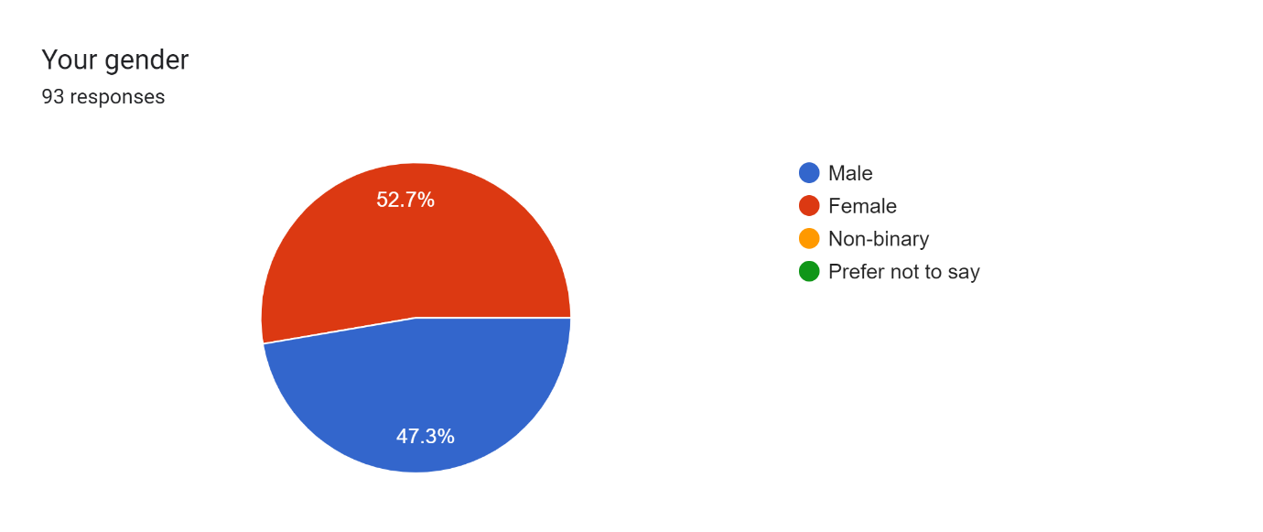

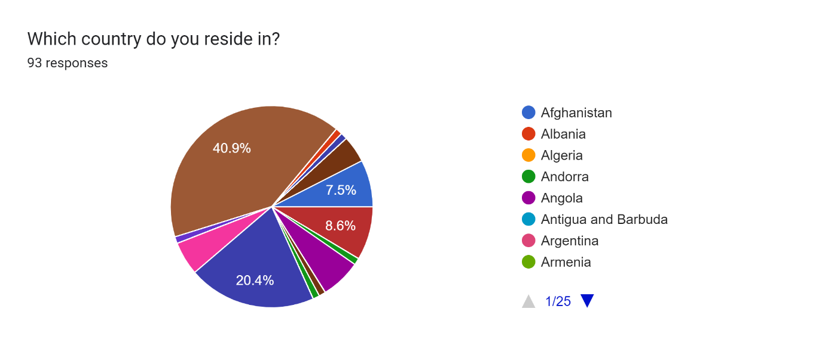

**3.3.2 Secondary Data Collection**

The **"Online Retail"** dataset from the UC Irvine Machine Learning Repository was chosen for secondary data analysis because of its detailed insights into customer purchasing behavior. This dataset contains transaction records from a UK-based online retailer, covering sales from December 2010 to December 2011. Each record includes essential information such as invoice number, product code, product description, quantity purchased, invoice date, unit price, customer ID, and the country of the buyer. The level of detail makes this data particularly valuable for understanding patterns, preferences, and behaviors within the retail environment.

The choice of the "Online Retail" dataset closely matches the objectives of this research, which aims to explore the potential benefits of a unified membership system. By analyzing patterns in buying behavior, such as how often customers purchase and which products are most popular, I can see how a combined membership system might improve customer engagement and loyalty. This data also allows for an in-depth look at customer preferences and repeat purchases, both of which are key to creating a membership system that meets the needs of both businesses and customers.

This dataset also provides a chance to test how well neural networks can predict customer behavior in a real retail environment. Since the dataset includes unique customer IDs and a record of each customer’s purchases, it enables me to build models that can suggest personalized recommendations and rewards. These insights show how a unified membership system could provide tailored experiences, leading to greater customer satisfaction and loyalty.

Overall, the "Online Retail" dataset from UC Irvine offers a strong base for the secondary data part of this thesis. Its rich, detailed transaction data supports the study of how neural networks can be used to create an effective unified membership system. Analyzing this dataset will add valuable insights and depth to the results and recommendations in this research.

**3.4 Data Analysis Techniques**

This section outlines the methods used to analyze both primary and secondary data collected for this research. By applying a combination of quantitative and qualitative techniques, this analysis aims to assess the feasibility of a neural network-based unified membership system and explore customer preferences.

3.4.1 Analysis of Primary Data

Survey Analysis: The survey data was analyzed using basic statistical methods to understand customer preferences for a unified membership system. Key metrics, such as percentages, averages, and response distributions, were calculated to measure customers’ interest in a unified system, the challenges they experience with managing multiple loyalty programs, and the features they would like to see. This quantitative analysis gives a broad view of what customers expect and highlights important factors that could guide the design of a unified membership platform.

3.4.2 Analysis of Secondary Data

Neural Network Model Testing: A simple feedforward neural network model was created and tested using the "Online Retail" dataset to predict customer behavior and measure engagement with a potential unified membership system. The model used information such as transaction history, customer ID, and purchase frequency as input data. To check how well the model works, performance metrics like accuracy, precision, and recall were calculated. These metrics help evaluate how accurately the neural network can predict customer purchasing patterns, which is important for creating a personalized membership system that could boost customer loyalty.

Transaction Data Analysis: The "Online Retail" dataset was also used to study customer buying patterns and group customers with similar purchasing habits. Clustering techniques were applied to divide customers into segments based on how often they buy, what products they prefer, and how much they spend. This segmentation provides a better understanding of different customer groups, helping to create personalized recommendations and targeted rewards in the proposed unified membership system. These insights are valuable for designing a system that meets various customer needs and enhances overall engagement.

**3.5 Sampling Strategy**

A combined sampling strategy was used to reach a broad group of respondents and gather diverse opinions on a unified membership system. Convenience sampling and volunteer sampling were chosen to maximize participation and collect data efficiently.

**Convenience Sampling:** The survey was shared online through social media and direct messages, making it easy for people in my network to access and complete. This approach allowed me to reach a wide audience quickly, gathering responses from individuals who were readily available and interested in participating. By using online channels, I could reach more people in a short period, which was essential given the project’s timeline.

**Volunteer Sampling:** To expand the sample beyond my online network, I also approached people in public places, inviting them to complete the survey on their phones or other devices. This in-person approach helped include respondents who might not have seen the survey online. To encourage participation, I offered small incentives, like sweets or a small amount of cash, which made people more willing to take part. This added variety to the sample and helped balance the data by including more perspectives.

Using both online and in-person sampling allowed me to reach a diverse group of respondents. This combination ensured that the sample reflected different backgrounds and experiences, adding depth to the insights gathered. Overall, this sampling strategy made it possible to gather responses efficiently while creating a more balanced and representative dataset for the research.

**3.6 Limitations of the Research Design**

While this research design provided useful insights into creating a unified membership system, several limitations affected the study.

First, because the topic is very specific—focusing on customer loyalty and membership integration—it was challenging to find data that perfectly matched the study’s needs. The available datasets didn’t fully align with the exact focus of the research, so the analysis had to rely on publicly available data that only partially represented the intended scenario.

Second, customer loyalty data is often considered private and confidential by companies, as it involves sensitive user information. Many businesses keep their customer data secure, which made it difficult to access detailed and up-to-date information on user behavior within loyalty programs. As a result, the study had to use publicly accessible datasets that may not capture the full complexity of customer interactions with loyalty systems.

Additionally, much of the data available online was outdated, which limited the relevance of the findings. Older datasets may not reflect current trends in customer behavior or the latest developments in loyalty programs and neural networks. This impacts the ability to draw conclusions that are fully relevant to today’s business environment.

Finally, the research was limited geographically, as much of the available data focused on specific regions or countries. This geographic focus makes it difficult to apply the findings broadly, as customer preferences and loyalty behaviors can vary significantly from one region to another. Because of this, the results might not fully represent global customer behavior.

**3.7 Ethical Considerations**

This research adhered to ethical standards to ensure the protection and respect of all participants involved in the study. The ethical considerations were primarily focused on obtaining informed consent, protecting participant privacy, and ensuring data confidentiality.

**Informed Consent**: All participants were fully informed about the purpose of the research and the nature of the data being collected. Before completing the survey, participants were provided with a brief introduction explaining the objective of the study and their role in it. Participation was voluntary, and respondents had the option to withdraw at any point without providing a reason. By completing the survey, participants indicated their consent to participate in the study.

**Anonymity and Confidentiality**: The survey was designed to protect participants’ identities, ensuring anonymity. No personally identifiable information, such as names or contact details, was collected, making it impossible to trace responses back to individual participants. All data collected was used solely for academic purposes related to this research, and access was restricted to the researcher to ensure confidentiality.

**Data Storage and Security**: The data collected through the survey was stored securely on a password-protected device, accessible only by the researcher. No data will be shared with third parties, and all collected information will be securely deleted upon completion of the research project to ensure privacy.

**Non-Harm Principle**: The study posed minimal risk to participants, as it involved gathering customer opinions on loyalty programs and membership systems without delving into sensitive or personal topics. Incentives, such as small sweets or nominal cash amounts, were offered to participants as a gesture of appreciation, without any form of coercion or undue influence.